**713H MOTOR GRADER SPECIFICATIONS**

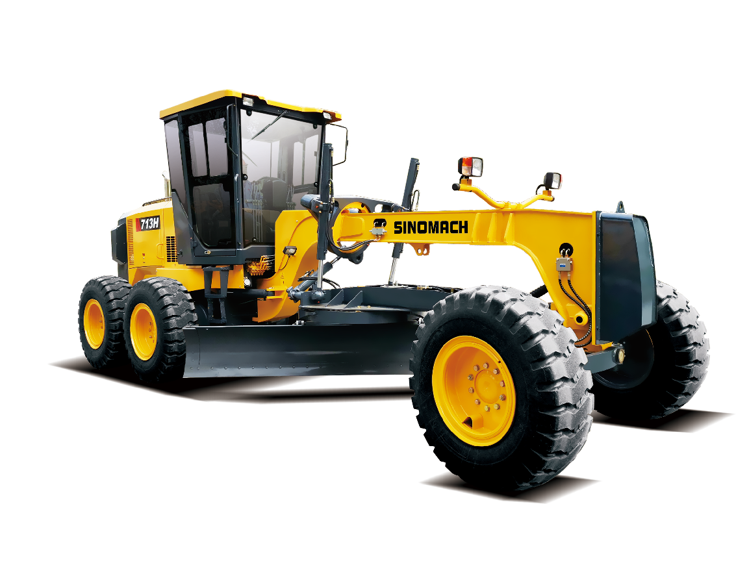

* **Sing-handle electro-hydraulic controlled power-shift T/M, 6forward & 3reverse shifts makes operation easy and convenient**
* **Hydraulic lock, auto lock/unlock NO-SPIN differential ensures stability and powerful traction**
* **Ideal axle load allocation provides excellent stability while cutting hard surface**
* **Serviceable, efficient hydraulic system enables every part to be fully used**
* **Reliable full hydraulic brake system ensures safety**
* **Box-typed frame and advanced T/M enable it to complete heavy-duty work**
* **A wide working range is accomplished through flexible blade suspension system and articulated frame**

| Overall Dimension整机尺寸 | | | | | | | | | | | | | | |
| --- | --- | --- | --- | --- | --- | --- | --- | --- | --- | --- | --- | --- | --- | --- |
| 1 | Length整机长度 | | | | | | | | | | | | | 8290mm |
| 2 | Width整机宽度 | | | | | | | | | | | | | 2600mm |
| 3 | Height(To the top of the cab)总高（到驾驶室顶部） | | | | | | | | | | | | | 3465mm |
| 4 | Wheel base轴距 | | | | | | | | | | | | | 5780mm |
| 5 | Tread轮距 | | | | | | | | | | | | | 2120(mm) |
| **Main Technical Specification主要技术参数** | | | | | | | | | | | | | | |
| 1 | Operating weight操作重量 | | | | | | | | | | | | 12000kg | |
| 2 | Blade length 刀板长度 | | | | | | | | | | | | 3658mm | |
| 3 | Blade height刀板高度 | | | | | | | | | | | | 580mm | |
| 4 | ShovelBlade thickness 铲刃板厚度 | | | | | | | | | | | | 16mm | |
| 5 | Traveling speed(Km/h)，6 forward and 3 reverse行驶速度，前六后三 | | | | | | | | | | | | | |
|  | (1) forward前进 | | | | | | | | 6.9/10.7/17.3/26/37.8/53.4 | | | | | |
| (2) reverse后退 | | | | | | | | 6.9/17.3/37.8 | | | | | |
| **Diesel engine发动机** | | | | | | | | | | | | | | |
| 1 | Model型号 | | | | | DongFeng Cummins 6BT5.9-C130 东康6BT5.9-C130 | | | | | | | | |
| 2 | Type型式 | | | | | Direct injection. Turbocharged. Water cooling  直喷、增压、水冷 | | | | | | | | |
| 3 | Rated output额定功率 | | | | | 97kW | | | | | | | | |
| 4 | Rated speed额定转速 | | | | | 2200(r/min) | | | | | | | | |
| 5 | Max. Torque最大扭矩 | | | | | 560(N.M)/1500rpm | | | | | | | | |
| **Transmission case变速箱** | | | | | | | | | | | | | | |
| 1 | Model型号 | | | | YD13 （CHINESE HANGCHI） | | | | | | | | | |
| 2 | Type形式 | | | | power shift, single-shift lever, natural-shift lock device  动力换挡、单手柄、中位自锁 | | | | | | | | | |
| 3 | Gear shift position档位 | | | | 6 Forward and 3 reverse gears前6后3 | | | | | | | | | |
| **Axle and Tire桥和轮胎** | | | | | | | | | | | | | | |
| 1 | | | Max. drawing force 最大牵引力 | | | | 61.7KN（f=0.75） | | | | | | | |
| 2 | | | Size of tire轮胎型号 | | | | 17.5-25-12PR(standard) 标配  13.00-24-12PR(optional)选配 | | | | | | | |
| **Working Device Hydraulic System工作液压系统** | | | | | | | | | | | | | | |
| 1 | | Model of tandempump  油泵型号 | | | | | | | | | HP51B678-07-07-7N | | | |
| 2 | | System pressure系统压力 | | | | | | | | | 17.5MPa | | | |
| 3 | | Model of distribution valve多路阀型号 | | | | | | | | | AX31112-1B,AX31112-2 | | | |
| 4 | | Model of oil motor回转马达型号 | | | | | | | | | EATON, JS-130 | | | |
| **Steering System转向系统** | | | | | | | | | | | | | | |
| 1 | Type形式 | | | Fore Tires deflexion前轮偏移式转向 | | | | | | | | | | |
| 2 | Model of redirector转向器型号 | | | | | | | | | BZZ5-E160B+FKB-3022 | | | | |
| 3 | System pressure系统压力 | | | | | | | | | 16MPa | | | | |
| **Brake System制动系统** | | | | | | | | | | | | | | |
| 1 | Type of service brake  行车制动系统型式 | | | | | | | Full hydraulic and inner-expanding brake  全液压内涨蹄式制动 | | | | | | |
| 2 | Oil pressure系统压力 | | | | | | | 10Mpa | | | | | | |
| 3 | Type of parking brake停车制动形式 | | | | | | | Mechanical and inner expand hoof brake  机械式内涨蹄式制动器 | | | | | | |
| **Oil Capacity油量** | | | | | | | | | | | | | | |
| 1 | Fuel(diesel)燃油箱 | | | | | | | | | | | 370L | | |
| 2 | Engine lubricating oil发动机机油 | | | | | | | | | | | 17L | | |
| 3 | Oil for converter and gear box变速箱 | | | | | | | | | | | 28L | | |
| 4 | Oil for hydraulic system液压系统 | | | | | | | | | | | 65L | | |
| 5 | Oil for driving rear axles后桥 | | | | | | | | | | | 18L | | |
| 6 | Tandem box 平衡箱 | | | | | | | | | | | 90L | | |