单钢轮振动压路机Single Drum Vibratory Rollers

GYS04YA/GYS04YB

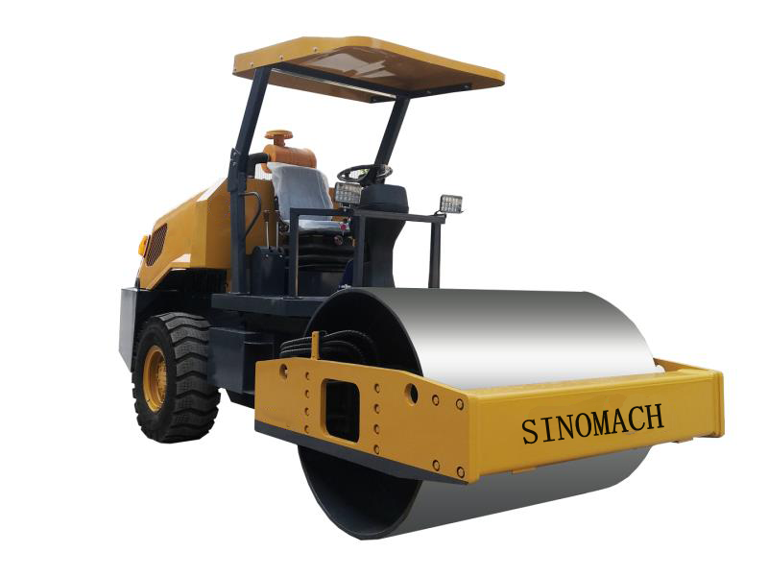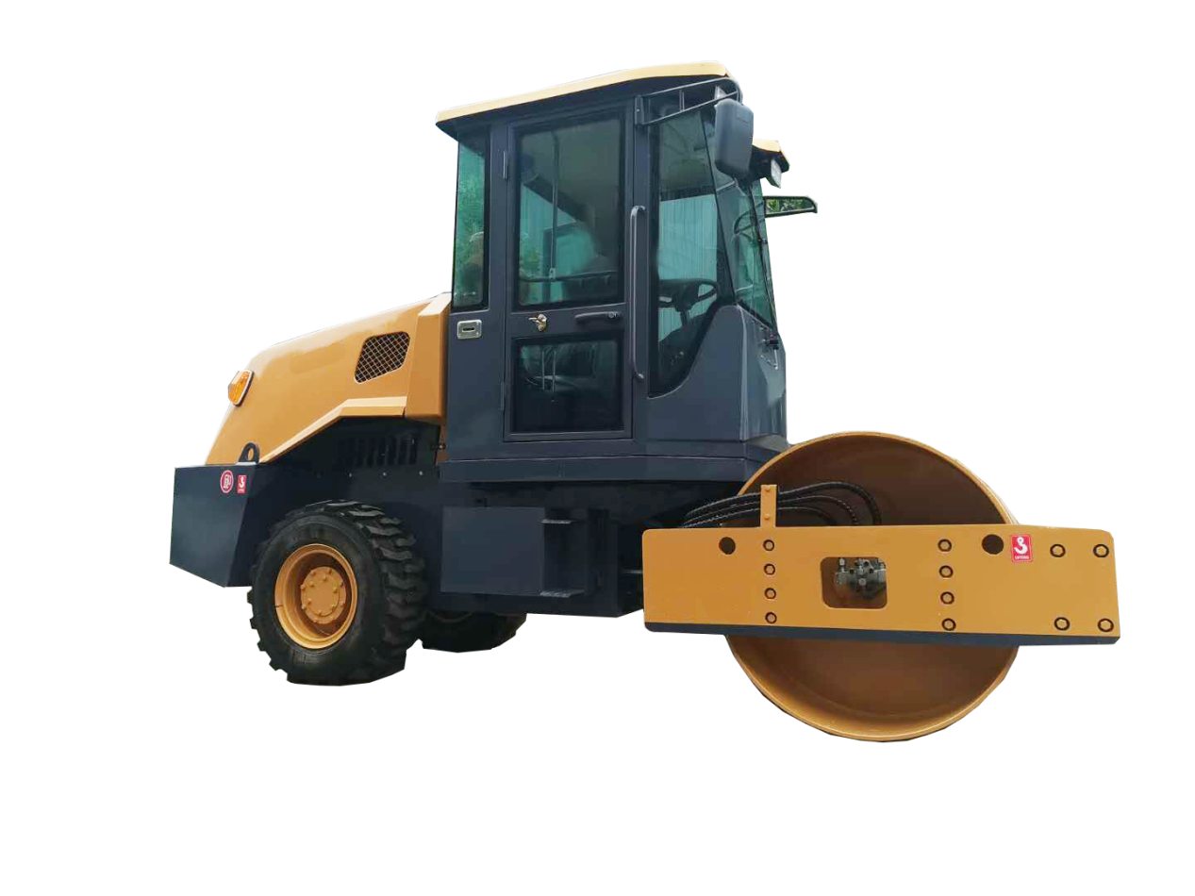

# 1 概述

* GYS04YA/GYS04YB是工作质量为4吨的机械式单钢轮振动压路机，本系列是中型振动压路机，主要适合于基础层、次基础层和填方工程中砾石、碎石、砂石混合料、沙性土壤和岩石填方等非粘性材料的压实，是建设高等级公路、铁路、机场、港口、堤坝及工业场地的理想压实设备。
* 液力变矩器传动，液压振动，铰接转向，整机机动灵活，具有可靠的性能和最佳的性价比；
* 该机采用常柴ZN490B四缸水冷发动机，耗油量低，性能好,适用于温度-10℃以上海拔高度2000m以下环境，排放符合国Ⅲ标准。
* GYS04YA标配伞棚，GYS04YB标配驾驶室
* GYS04YA/GYS04YB is a 4 ton mechanical vibration roller with single steel wheel，Heavy duty vibratory rollers are suitable for compaction of non-cohesive materials such as gravel, crushed stone, sand-macadam mixture, sandy soil and rock filling etc. on base course, sub-base and embankment fill construction etc., which are ideal equipment for high-class highway, railway, airport, harbors, dams and large-scale industrial ground etc.
* hydraulic torque converter travel drive, hydraulic vibration and articulated steering and the whole roller with optimal function/worth ratio and reliable performance.
* To adopt Chang Chai ZN490B engine, satisfies the requirement of GUO Ⅲ emission, low fuel consumption, performance is good.apply to the temperature - 10 ℃ above altitude 2000 m below the environment.
* GYS04YA standard canopy, GYS04YB standard cab

## 2 技术参数表

|  |  |  |  |
| --- | --- | --- | --- |
| **项目** | **内容** | **单位** | YSW204A/YSW204B |
| 质  量  参  数 | 工作质量Operating mass | kg | 4000 |
| 前轮分配质量 | kg | 1800 |
| 后轮分配质量 | kg | 2200 |
| 静线载荷Static linear load | N/cm | 140 |
| 机  动  性  能  参  数 | 工作速度travel speed | km/h | 1.8/6.3 |
| 理论爬坡能力 grade ability | % | 35 |
| 最小转弯外半径 turning radius | mm | 4500 |
| 最小离地间隙ground clearance | mm | 310 |
| 轴距 wheelbase | mm | 2230 |
| 转向角steering angle | ° | ±20 |
| 摇摆角angle of oscillation | ° | ±5 |
| 压  实  参  数 | 振动频率vibrational frequency | Hz | 50 |
| 名义振幅amplitude | mm | 0.5 |
| 激振力(高频/低频)centrifugal force | kN | 60 |
| 压轮直径drum diameter | mm | 1000 |
| 压实宽度drum width | mm | 1270 |
| 发  动  机 | 型号 diesel model |  | 常柴 ZN490B |
| 型式 diesel type |  | Four cylinder、water ccooled |
| 额定功率diesel power | KW | 36 |
| 额定转速diesel rotational speed | r/min | 2400 |
|  | 外形尺寸Overall dimensions | mm | 4030*1400*2450 |